Beauty and Joy of Computing Unit 5 Assessment
Similar to your work in Lab 2, Contact List, write a data analysis program that meets all of the following specifications:
- Includes one data set from the CORGIS Datasets Project.
- Filters the data in a single column of a portion of your data set by using keep.

For example, if your data set provides nutritional information for a variety of foods you could analyze the protein content (provided in one column of the data) of all the infant formulas (a portion of all the types of food).
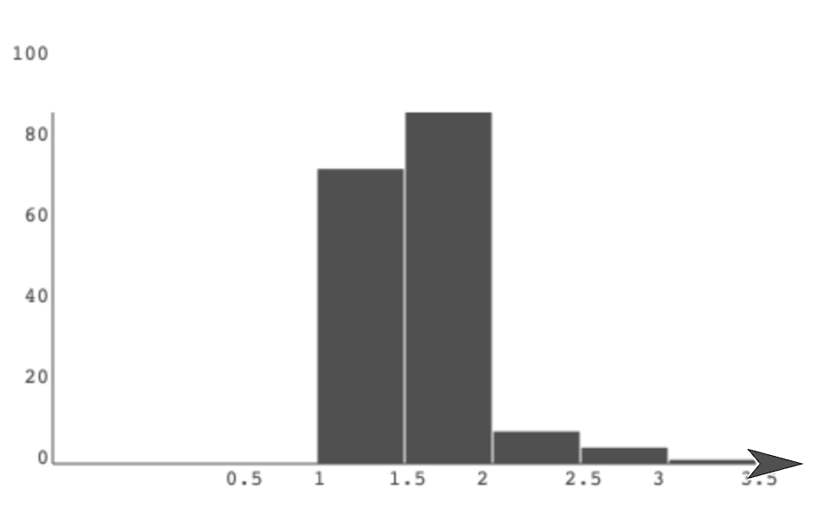
- Processes the data to conduct three separate mathematical analyses of the same single column of a portion of your data set.

For example, you could determine the following:
  - The average value
  - The maximum value
  - The count of how many data points have value above or below a certain threshold

- Plots the same single column of a portion of your data set that you analyzed using the BAR CHART and PLOT BAR CHART blocks from the "Bar Charts" library.

